**Create a social media calendar**

If you are taking this course in order, you may have watched the video on creating a social media calendar. The video covers each step you should take when building and using a social media calendar. To recap, these steps are:

* Identify social media platforms
* Review, or audit, current platforms and content
* Decide which data you want to track
* Make a content library, containing all postable materials
* Establish a workflow and review process
* Craft and schedule posts

In this reading, you will review some benefits of using Google Sheets as a social media calendar. Then, keeping what you have already learned in mind, you will learn how to add content to a calendar using templates.

**Using Google Sheets as a social media calendar**

Google Sheets is completely customizable and free to use. You can create a calendar that fits your company’s needs, especially if they don’t have a huge budget.

Below is an example of a calendar for a dog food company called Best for Dogs.

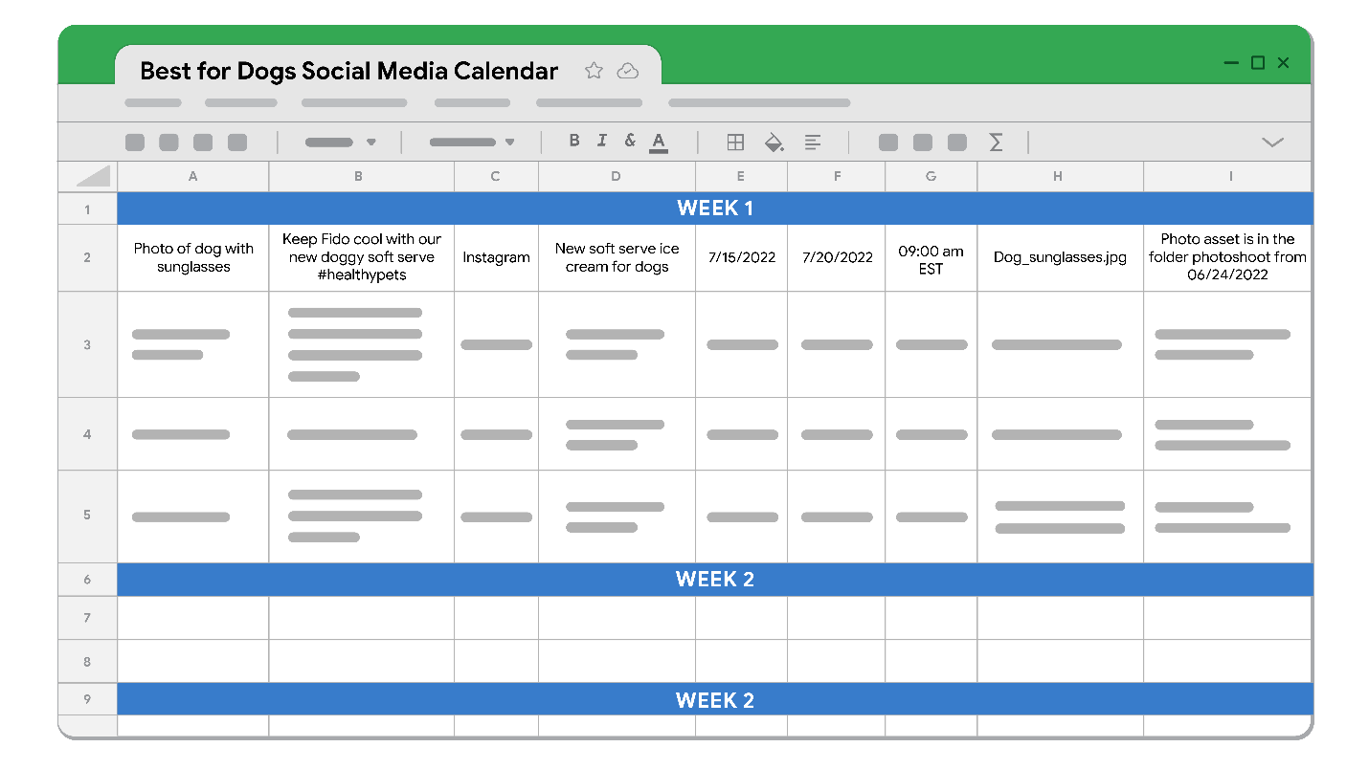

This social media calendar includes detailed information, so that anyone on the Best for Dogs team can easily understand what should be posted that day. Information such as the concept, social copy (or caption), channel, topic, posting date, location of postable assets, and other important information help to make the posting process as smooth as possible.

To best understand Google Sheets, you should practice using its features. You can access this template by [clicking here](https://docs.google.com/spreadsheets/d/1x50OJ7kJTpKEuhfdWZfnpqwpY1i2we6ZngZag9kDvy8/template/preview#gid=0). After you’ve opened it, click on ‘Use Template’ to make a copy. (To download an Excel version of the template, go to the *Resources for more information* section below.)

**Note:** To create a new month, right click the *Blank Template* tab and click ‘duplicate.’ Then, right click again, click ‘rename’ and type in the month name. You are now ready to fill out a new month!

**Pro tip:** Hootsuite offers its users an internal social planner that integrates directly with Google Sheets. You can find more information below.

**Resources for more information**

You can download the Social media calendar template from the attachment below:

For more help building out social media calendars, visit the following links:

* [Hootsuite](https://blog.hootsuite.com/how-to-create-a-social-media-content-calendar/#How_to_create_a_social_media_calendar): How to create a social media calendar: Tips and templates
* [Asana:](https://asana.com/resources/social-media-content-calendar) Your 6 step guide to creating and managing a social media content calenda